Human Capital Management
Core Business Process
FC Platinum Holdings (PVT) LTD is committed to the implementation of a planned and systematic recruitment policy that gives equal employment opportunity. It specializes in providing and supplying skilled and unskilled labour to clients. Its employees are assigned to clients for a fixed duration. FC Platinum aims to be the leading labour broker in Zimbabwe; serving the needs of clients across all industries and providing employment for the nation’s citizens.
Labor Request Management
Labour request management is the process of soliciting employees and managing the entire recruitment process by the FC platinum Human Resources department. The request can either be for a new employee or employee renewal.
New employee is a worker who hasn’t worked for FC Platinum before and a renewal is an employee who has worked for FC Platinum and is present in the FC Platinum past workers labour pool.
There are two types of requests i.e. Labor broking labor request and admin labor request.
  - Labour Broking Request (External)
This is when the Customer requests FC platinum to provide labour to fill gaps in its Brokered Labour pool.
Requests can also be requested for shutdown (routine mine maintenance) staffing
  - Admin Request (Internal)
This is when FC Platinum recruit employees to work for FC Platinum Holdings administrative function.

Functional Prerequisites
The following is a list of the prerequisites that need to be defined to start the Labour request management process.
- Dimensions
Dimensions can either be Customer specific or FC platinum specific.
FC platinum has the following main dimensions associated with labour broking, Business Unit, Department and Cost center
For each customer a Dimension mapping matrix will be used to map customer dimensions and FC platinum dimensions for accounting purposes.
Attached Below is a sample Dimension Map for Mimosa Mine.
- Grade
A grade identifies the pay level of a Job at FC Platinum. A grade is a prerequisite of a Job.
FC Platinum Currently has the following grades defined
- Jobs
Jobs are general classifications for sets of tasks or functions that an employee is required to perform at FC platinum Holdings. One Job can map to many positions and must belong to one grade A job is a prerequisite to creating a position.
FC platinum currently has the following Jobs defined,
- Position
Positions represent the post that can be occupied by a person in staffing assignments at FC platinum. Positions are specific and must belong to a business Unit, Department and cost Centre. Each Position is typically occupied by one employee. A Position can how ever be filled by more than one employee. Positions can be 100% filled, partially filled or vacant.
FC platinum currently has the following Positions defined
- Skills

A skill is the ability to carry out a task and employees at FC platinum can be classified into two segments skilled and unskilled.

- Medical Certificate

- Pay point
Pay point refers to the allocation of payroll input to specific payroll personnel in the payroll section. The input is segregated based on a provided department and the resultant payroll cost is directly allocated to the identified department. In the case of FC Platinum, the grouping is based on departments i.e. Mining, MHL, Survey, Plant etc.
FC platinum currently has the following pay points defined
- PPE Matrix
Pay point refers to the allocation of payroll input to specific payroll personnel in the payroll section. The input is segregated based on a provided department and the resultant payroll cost is directly allocated to the identified department. In the case of FC Platinum, the grouping is based on departments i.e. Mining, MHL, Survey, Plant etc.
FC Platinum has the attached universal PPE Matrix in use.

- Contract type
FC Platinum holdings has 12 (Twelve) different contract Templates namely:
- FC Admin (Probation / Without Probation)
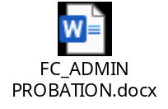
- FC Admin Assigned (Probation / Without Probation)
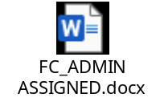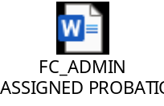
- FCP Casual

- LT LBR (Probation/without Probation)

Platinum Precision Engineering four different contracts namely:
- LT PPE (Probation/without Probation)

- PPE Artisan Assigned

- PPE Casual

- PPE Chargehands

Recruitment & Selection

Capturing a labour request

Precondition

- Position
The position intending to be filled must have been created.
- Need of labour
A staffing fulfillment requirement must exist either internally or from FC platinum customers.

Process Description

The requesting department or customer sends a request for labor to the Human resources department. The HR officer receives a completed and Authorized physical labor request form. He/she captures the labor request for the department/customer in need of labor and the number of positions required for the labor request.
When capturing the labor request the HR officer then notes the labor request ID and creates an internal reference for internal tracking.
A shutdown Project ID must be assigned to all shutdown related labour requests
Attached below is a sample of the physical Labour Request Form.

Labour requests can be grouped with the following statuses
Open (Has been captured and saved but Awaits Resource allocation)
In Process (Is partially filled but still has open positions)
Closed (All positions have been completed)
Expired (has reached its Request end Date weather it is filled or still in process)

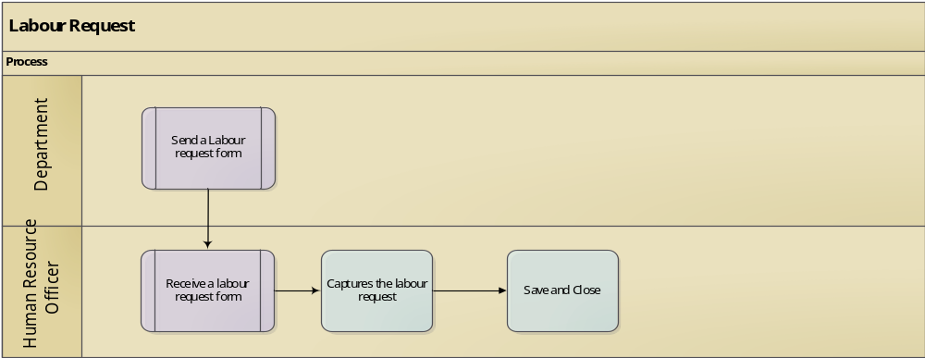

Actors
- Labour Requisitioner.
- HR Officer.

Work Flow
- None Required

Audit Trail
- Labour Request ID.
- Labour Request Internal Tracking ID.
- Labour Request Status.
- Shutdown ID.

Recruitment - Onboarding

Precondition
- New Employee
The selected candidate must not have worked for FC platinum before in any capacity.
- Previous employee record
FC Platinum should have a previous employee for the Employee but the contract has expired.
- Medical Certificate
Selected candidate must have a valid medical certificate.
- Shutdown ID
Identifier of Shutdown

Process Description

The initiator selects a Labour request to action. If the selected resources is a new employee the initiator captures new employer contract details. If the selected resource is a renewal employee the initiator filters the employee from the employee labor pool and updates the employee contract details.
Medical Certificate details and status must be added or amended at this point.
The required Skill, Mine Number, Previous Job or Position can be used to filter a resource from the past workers pool.
Once employee contract details have been captured the initiator send the new employee record for approval.
Attached is a Template that has the contract types and fields that available for use on each contract.

Contracts that do not have the Recruitment prerequisites (Medical Certificate & Mandatory Contract fields) will not be available for submitting for approval.
Once the resources contract is approved it is available for Printing.
Note:
Employees (Casual Worker) engaged by FC Platinum for a total 6 weeks in (4) four months should not be available for renewal until after four months.

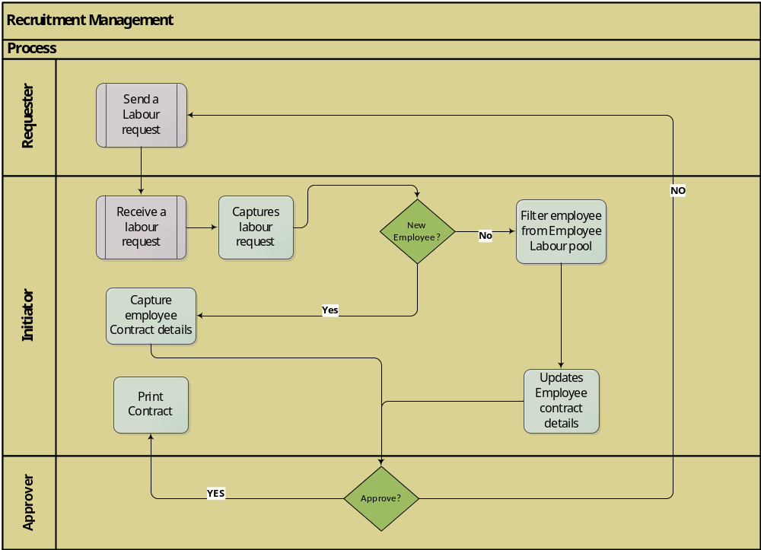

Actors
- Requester
- Initiator
- Approver

Workflow & Notification
- Initiator submits recruitment workflow for approval
- Approver approves recruitment workflow
The following approval levels apply for recruitment.
Contract Class | Requester | Initiator | Approver
FC Admin | FC Platinum | HR Officer | HR Superintendent
Labor Broking | Mimosa | HR Assistant | HR Officer

Audit Trail
- Mine Number
- Position
- Assignment Start Date
- Assignment End Date
- Department
- Cost centre

Contract Printing.

Precondition
- Employee recruitment
The employment status should be Employed.

Process Description.

The Employee contract record with relevant mine number can be selected for contract printing
For Shutdown projects a mass printing can be scheduled by selecting a Shutdown ID and printing all the contracts in the shutdown project.
Contracts must be archived in archive for future reference

Actors
- Initiator (Human Resources Officer or Human Resources Assistant)

Workflow
- None Required

Audit Trail
- Contract ID
- Shutdown ID

Request for PPE
Personal Protective Equipment selection matrix based on existing guidance from the SHE department for diseases and harm, control and prevention. The matrix directs users to which types of PPE to wear based on certain work activities or potential exposures.

Preconditions

- Active Employment Contract
- Type of Request (New, Anniversary, Incident)

Process Description

The request for PPE is handled as follows,
- New Employee
After a new employee is recruited the HR Assistant raises an internal requisition for PPE for the New Employee. The Configured PPE matrix will then be used to determine the relevant PPE equipment to issue and the applicable anniversary dates for Equipment issued.
The Request is forwarded to the Head of Section (HR Officer) for Approval. Once the approval has been granted the request will be routed to Stores (Accounting Assistant -Inventory for issuing).

- Anniversary
When Employee PPE has reached the Anniversary, the Employee raises a requisition for new PPE. The HR Assistant Checks the Employees PPE Issued Status against the PPE Matrix. If the PPE has reached anniversary the HR Assistant raises an internal requisition for the Employee’s PPE renewal. The Configured PPE matrix will then be used to determine the relevant PPE equipment to issue and the applicable anniversary dates for Equipment issued. The Head of Section (HR Officer) approves the requisition for renewal PPE. Once the requisition is approved the request will be routed to Stores (Accounting Assistant -Inventory for issuing).
- Incident
An incident is when employees PPE has been damaged or stolen before it has reached its anniversary date. The employee must fill an incident report which is signed by the Head of Section (HOS), Head of Department (HOD) and the SHE Officer.
Once the incident report has been signed, the Employee submits the requisition of new PPE together with the incident report to the HR Assistant. The HR Assistant marks out the old damaged PPE and raises an internal requisition for PPE incident renewal. The Configured PPE matrix will then be used to determine the relevant PPE equipment to issue and the applicable anniversary dates for Equipment issued. The Head of Section (HR Officer) approves the requisition for incident renewal PPE. Once the requisition is approved the request will be routed to Stores (Accounting Assistant -Inventory for issuing).
NB: Employee must leave the old damaged PPE to the Accounting Assistant -Inventory upon issuing of new PPE.
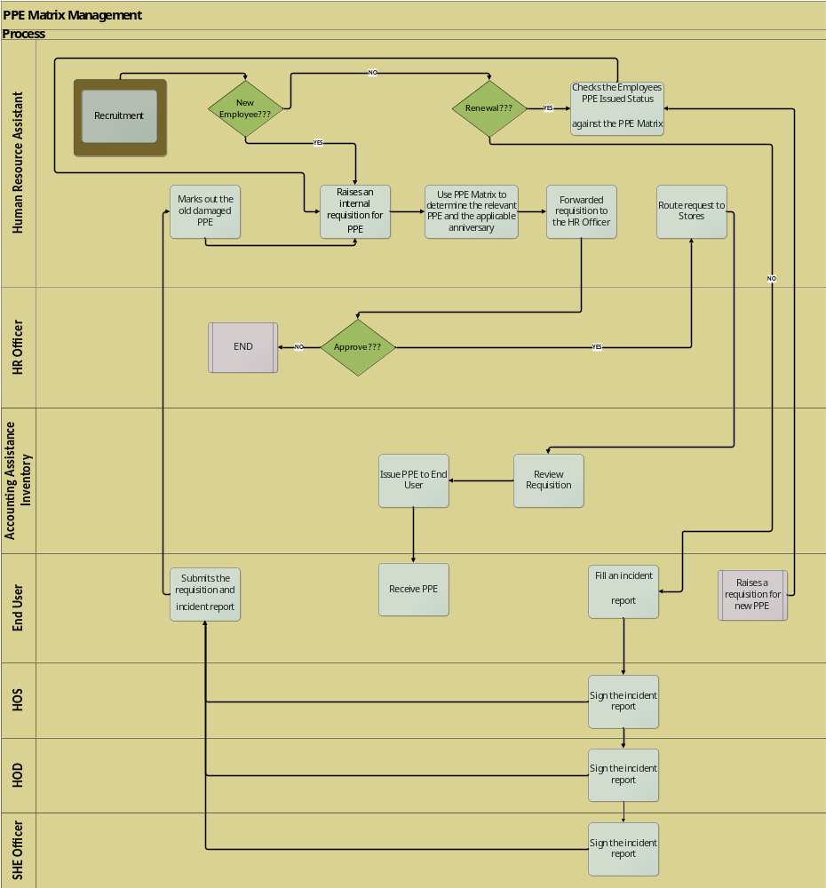

PPE Request Form Field Description

Actors
- End user
- HR Assistant
- HR Officer
- Accounting Assistance Inventory
- Head of Section
- Head of Department
- SHE Officer

Workflow/Notification
- Originator request for approval
- Head of Section approval of PPE requisition from end user

Audit Trail
- PPE Id Number

Induction

Precondition
- Employee recruitment
The employee should have recruited and assigned a position for the contract to be onboarded.
- Contract
The employee should have signed a contract for one to be onboarded.

Process Description
After recruitment and selection and employee contract management, the process of integrating a new employee with a company and its culture is performed using an induction form.


Actors
- HR Officer
- Employee

Workflow
- None

Audit Trail
- None

Employee Management

Time Management

Prerequisites

FC Platinum Labour Broking Timesheet

Precondition
- Attendance
Employee should have attended to work for one’s time to be managed.

Process Description
FC Platinum clerk fills in a log book on a daily basis on all the employees who report to work every morning. On a specific date agreed on the FC Platinum Clerk together with the Mimosa Clerk conduct a reconciliation on their log books. Every HR Clerk is allocated a section in which he creates timesheets for. The HR Clerk uses the two log books from Mimosa and FC Platinum clerks to fill in the timesheet, recording employees total working hours, overtime worked and all leave days taken.HR Clerk then attaches the timesheet with the overtime authorization form, leave form and acting appointment form (sample forms attached below). Acting appointment form is a form that is used when an employee is asked to work on behalf of their immediate supervisor for the time there are off-duty.
The documents are forwarded to Mimosa Management for verification and signing. The Hr. Clerk receives the signed time sheet and produces a Summary Sheet (sample document below). The summary sheet together with the overtime authorization form, leave form and acting appointment form are forwarded to the HR Assistant to review and authorize. The HR Assistant forwards the attached documents to the HR officer for approval. The HR Officer after reviewing and approval will forward the attached documents to the Payroll Officer and Accounting Officer Inventory and Revenue for further processing.
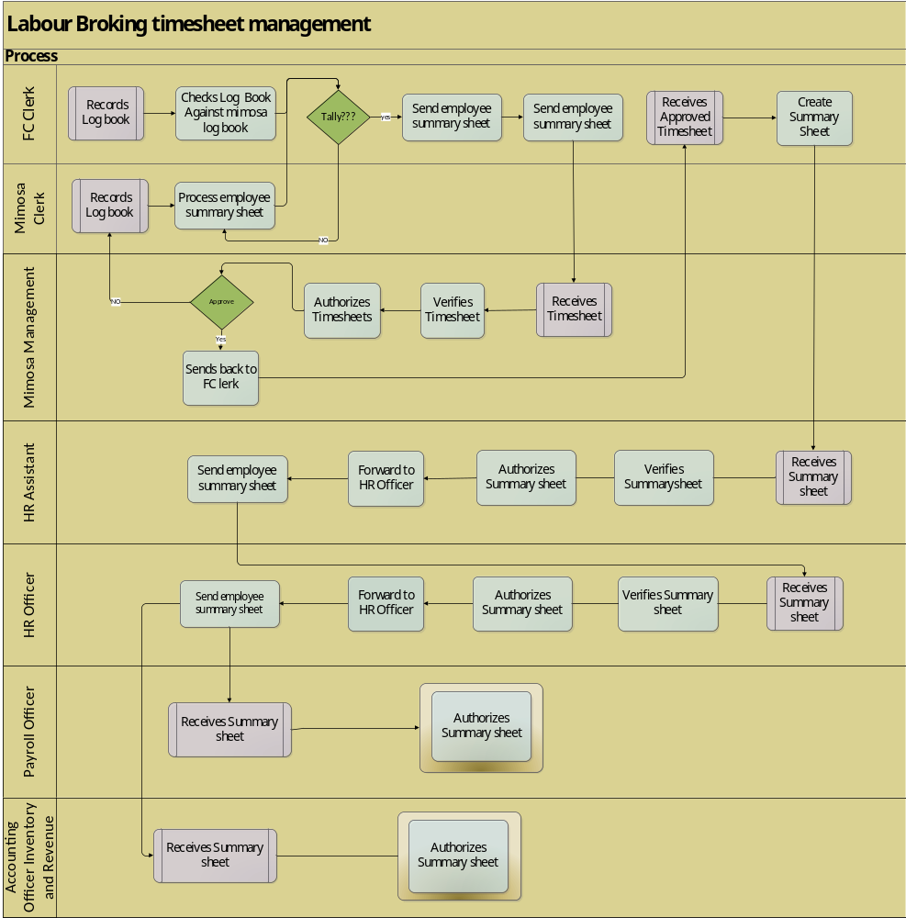

Actors
- Head of Department
- HR Officer
- Payroll Officer
- Mimosa Management
- HR Clerk
- HR Assistant Officer
- Mimosa Clerk
- Accounting Officer Inventory and Revenue

Workflow
- Request for approval from HR clerk
- Approval from Mimosa Management

Audit Trail
- None

FC Platinum Internal Timesheet

Precondition

Process Description
The FC Platinum department clerk fills in the timesheet, recording employees total working hours, overtime worked and all leave days taken. The Clerk then attaches the timesheet with the overtime authorization form, leave form and acting appointment form (sample forms attached below) . Acting appointment form is a form that is used when an employee is asked to work on behalf of their immediate supervisor for the time there are off-duty. The documents are forwarded to the Head of Department for verification and signing. The Hr. Clerk receives the signed time sheet and produces a Summary Sheet (sample document below). The summary sheet together with the overtime authorization form, leave form and acting appointment form are forwarded to the HR Assistant to review and authorize. The HR Officer after reviewing and approving will forward the attached documents to the Payroll Officer for further processing.
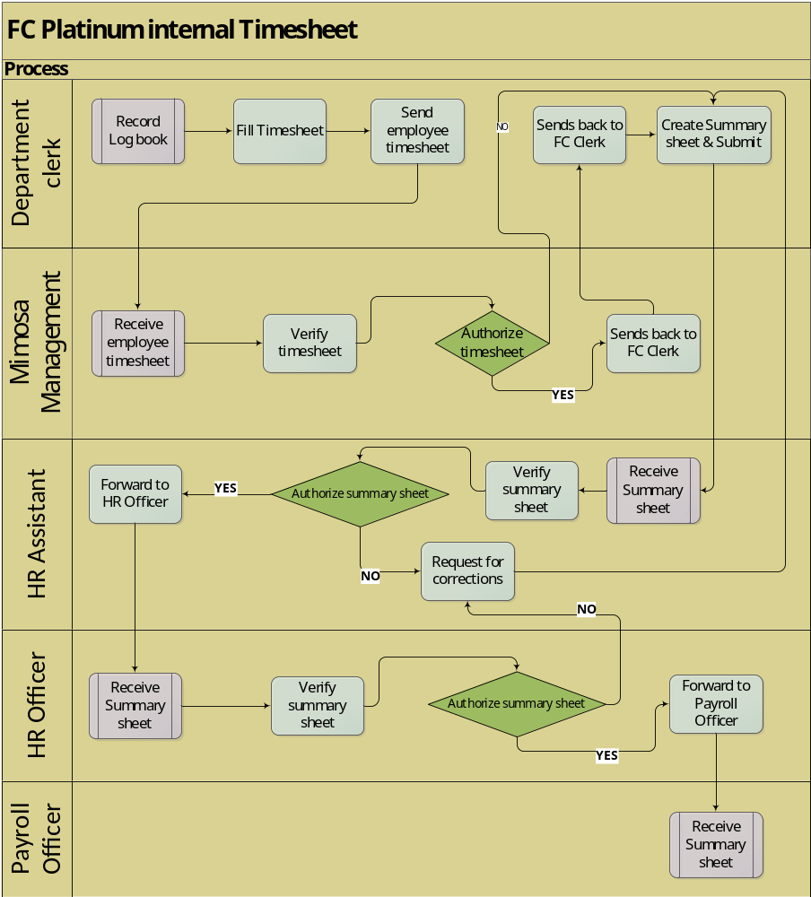

Actors
- Head of Department
- HR Officer
- Payroll Officer
- Clerk

Workflow
- None

Audit Trail
- None

Leave Management
Core Business Process
This is a is an arrangement granted to an employee who needs to be absent from the work during working hours. They are two types of leaves i.e. Paid and Unpaid leave. Paid leave has 2.5 days per month. Unpaid leave is an arrangement granted to an employee who needs to be absent from the work during working hours but not paid.
There are two types of leave managements i.e. Labor broking leave management and admin leave management.

Prerequisites
- Active Contract
Employee should have an active contract.

Labour Broking leave management

Precondition

Process Description
The employee fills a leave form specifying type a leave and period and submit it to the Supervisor for approval. The leave form goes through all client approvals. Once approved the employee submit the leave form to the HR Assistant who is responsible for the client sector. The HR Assistant receives the leave form and confirm employee leave days. Once the leave days are confirmed the leave form is submitted to the HR Officer for final approval. Once approved, the leave form is submitted to the Payroll officer waiting for its timesheet.
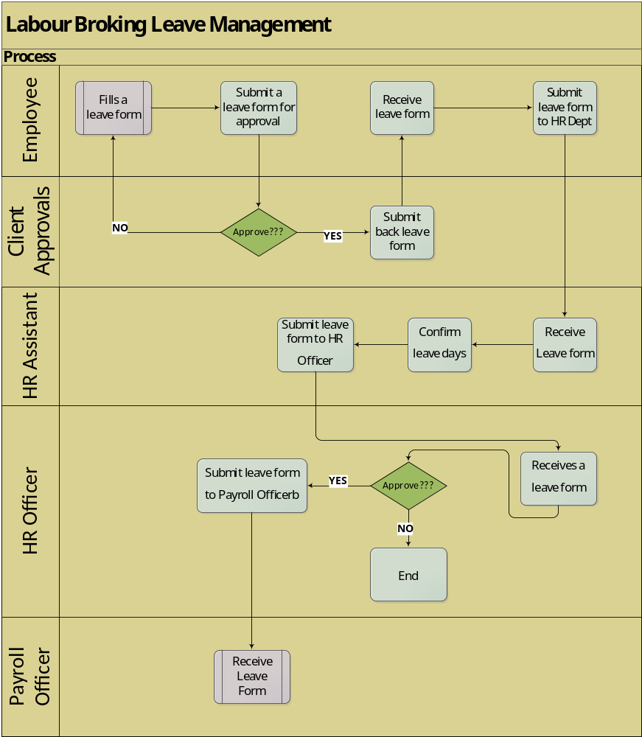

Actors
- Employee
- Head of Section
- Head of Department
- HR Assistant
- HR Officer
- Payroll Officer

Workflow
- All client supervisor approvals
- Approval of Leave by HOS
- Approval of Leave by HOD
- Approval of Leave by HR Officer

Audit Trail
- Reason for leave

FC Admin leave management

Precondition

Process Description
The employee fills a leave form specifying type a leave and period and submit it to the Head of section for approval. Once approved by HOS is the submitted to the Head of department for approval. Once approved the employee submit the leave form to the HR Officer for final approval. The HR Officer receives leave form and confirm employee leave days. Once the leave days are confirmed the leave form is finally approved. Once approved, the leave form is submitted to the Payroll officer waiting for its timesheet.
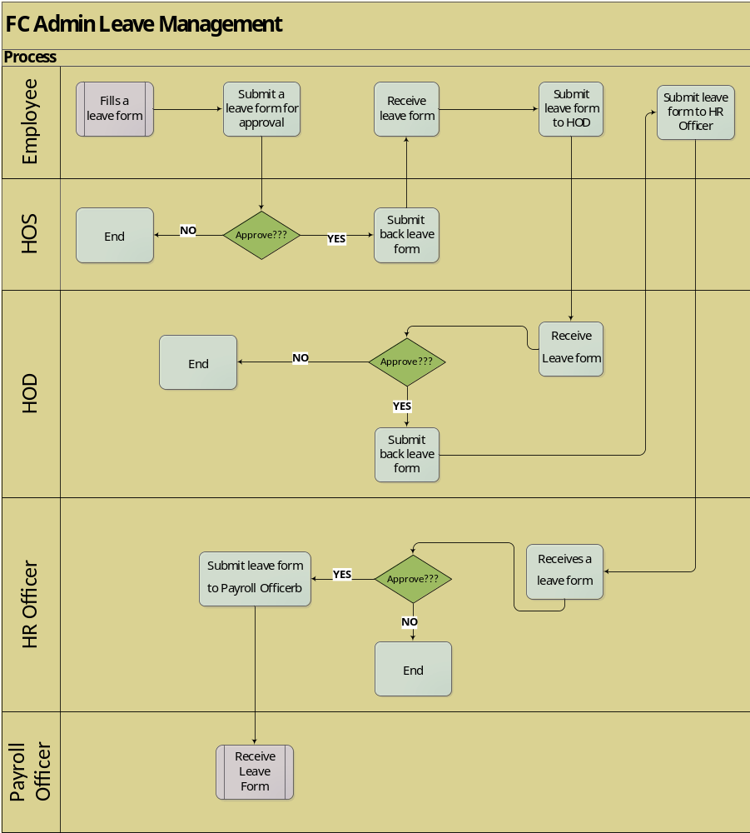

Actors
- Employee
- Head of Section
- Head of Department
- HR Officer
- Payroll Officer

Workflow
- Approval of Leave by HOS
- Approval of Leave by HOD
- Approval of Leave by HR Officer

Audit Trail
- Reason for leave

Acting Appointment Management
Acting appointment is when one employee is assigned to act on another employee’s position when he/she is on leave. The acting employee is paid using either differential or percentage. Differential is the salary difference of the acting employee and employee on leave therefore acting employee get his/her salary plus the difference. Percentage is when an acting employee is paid his salary plus a certain percentage of the absent employee depending on the type of position.

Precondition
- Absent Employee
One employee must be on leave for one to act upon another.

Process Description
In the even that an employee is absent from work due to different reasons (Sick leave, Study leave, Business travel, etc.) another is employee is appointed to act on behalf of the absent employee. The Payroll officer then review the salary of the employee acting upon the absent employee.
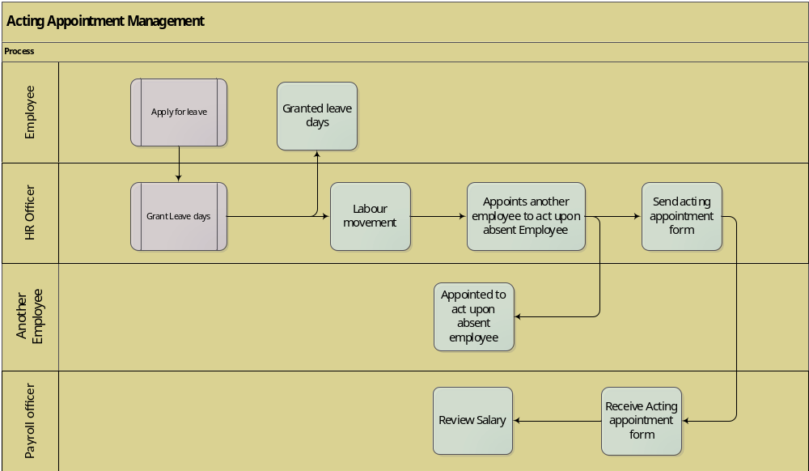

Actors
- Absent employee
- Acting employee
- HR Officer
- Payroll Officer

Workflow
- None

Audit trail
- None

Labour Movement Management
This is a document used when an employee is moved from one position to another, this affects the employees’ Grade and also when an employee is acting upon another absent employee’s position.

Precondition
- Change in Job position
When an employee is changed his/her position within FC Platinum Holdings
- Change in Job grade
When an employee’s grade is changed labor, movement occurs
- Acting Appointment
When one employee is acting on an absent employee labor movement occurs

Process Description
If one employee goes to leave another employee is appointed to act on the absent employee using labor movement. Also, if there’s a change of job for an employee, grade is affected therefore labor movement is used.

Actors
- HR Officer
- Employee

Workflow
- None

Audit trail
- None

Industrial Relations Management
Industrial relations explain the relationship between employees and management which stem directly or indirectly from union-employer relationship. Maintaining good employee relations is important to the success of an organization and common employee relations issues include conflict management, hours and wages issues, adequate safety in the workplace, annual leave disputes, timekeeping and attendance issues the list is endless. However, there is a process in place designed to address all these prevailing issues.

Precondition
- Conflicts
These are issues or misunderstandings which occurs between employees and management, or between employees, or between management.

Process Description

The process begins when the notification of offence is handed over to the HR Officer. The HR officer has the responsibility assign the case to the appropriate Industrial Relations Clerk who then to creates a case and records all the necessary case details namely

Case ID
Accused
Case Description
Case Status
Complainant
Status
Hearing Official

Cases are grouped in the following case categories.

Absenteeism
- AWOL
Sub Standard Performance
- Incompetency/inefficiency
Indiscipline /Disorderly Conduct
- Alcohol Abuse
- Theft
- Gross negligence

The HR officer then arranges for a properly constituted hearing team to hear the case.

The following verdicts can be reached

Counselling (Verdict validity)
First Written Warning (Verdict validity)
Second Return Warning (Verdict validity)
Severe written Warning (Verdict validity)
Final Return Warning (Verdict validity)
Dismissal (Verdict validity)
Re-Instated (Verdict validity)
Case Withdrawn (Verdict validity)
Case Withdrawn (successful appeal) (Verdict validity)

Once a verdict has been reached the verdict start date plus the Verdict Validity will give the verdict expiration date. 1

If the accused is not happy with the verdict, they can lodge an appeal with the HR officer who then forwards the Appeal to the Appeals officer.

When recording an Appeal, the following details must be captured.
Appeal Date
Appeal Description
Appeal Notes
Appeal Verdict (
Verdict Date
The Appeals Officer will review the case and give a final verdict on the case. They can either uphold the previous judgement rescind it or change it.

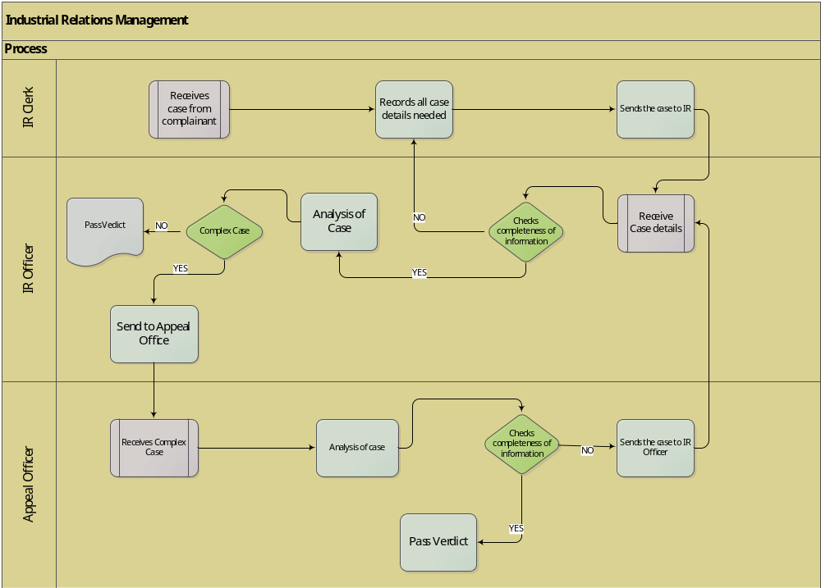

Actors
- Employee
- Industrial Relations officer
- Appeal officer
- Industrial Relations Clerk

Workflow & Notification
- HR officers approve case

Audit trail
- Case ID

Termination Management
Termination is the process of ending employee’s contract. Terminating the contract might be due to any one of the following reasons
- end of contract period,
- or employee has committed an offense at a work place
- employee decided to leave due to personal reasons.

Pre -condition
- Contract expiry
  - Active Contract.
- Reason for Termination.
  - Dismissal has been given as verdict of a hearing.
  - Employee has resigned.
  - Contract has Expired.

Process Description
When the intent to Terminate employment has been approved the employee gets a clearance form and goes through the following department for clearance:
- Human Resources (Housing)
- Accounts
- Information Technology
- Bank Loan
- Hospital
- Stores
This is done to ensure that the employee returns all financial liabilities and equipment that have been assigned to the employee. If the employee owes any financial liability or equipment the Head of Section puts a comment on the clearance form. When the clearance form gets to Finance department the Accounting Officer puts the value of equipment and or financial liabilities. Clearance form finally is cleared by the payroll officer. The payroll officer checks and verifies the clearance forms with the Head of Sections (HOS).

If the employee owes FC Platinum then the Payroll officer deducts the amount from Employee’s Terminal Benefits. After clearance process, the HR Officer terminates the contract.
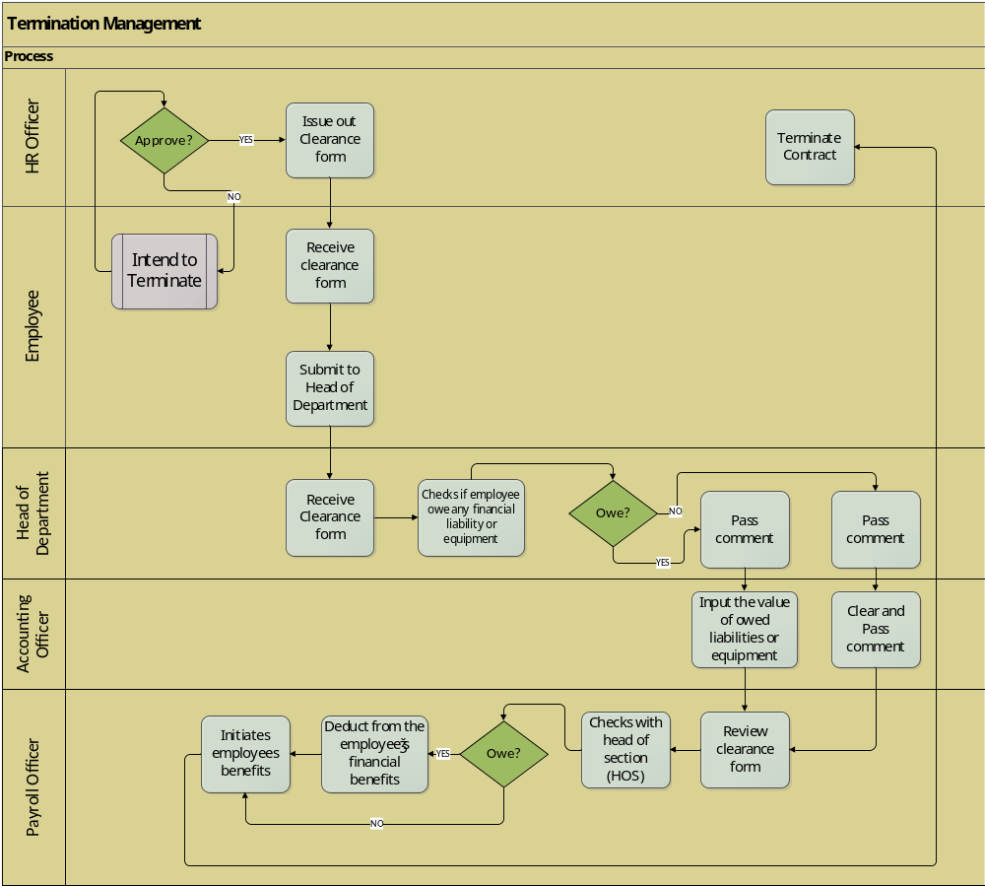

Actors
- Head of Section (HOS)
- HR Officer
- Employee
- Finance Officer
- Payroll Officer

Workflow & Notification
- Workflow -Approval for Employee termination
- Notification for expiry of contract (1 month & 2 weeks)

Audit trail
- Termination reason

Integration Management
Time sheets and summary sheet integration to Payroll. (Labour Broking & FC admin)
Core Business Process
Is the process of integrating the summary sheets to the Payroll department and the Accounts Receivable. The following integrations are required at FC Platinum Holdings to allow the seamless flow of data from Human Resources to Payroll and to Accounts Receivable (invoicing).
- Contracts Integration to Payroll
- Time sheets and summary sheet integration to Payroll. (Labour Broking & FC admin)
- Time sheets and summary sheet integration to Accounts Receivable (Labour Broking)

Contract Integration

Pre-Condition
- New Employee or renewal

Process Description
Payroll Officer receives the contract files from Human Resource Officer after recruitment completion. The Payroll Officer verifies the contract details with the physical contracts sent to HR. If they are any changes required, they will advise HR to amend the Employee record. Once all is verified, they save the following details in the Master File.

Name | Type | Length
Contract Number | String | 6
Contract Type | String | 6
Personnel Number | String | 6
Name | String | 25
Surname | String | 25
Employment Start Date | Date | 25
Employment End Date | Date | 25
Pay point | String | 25

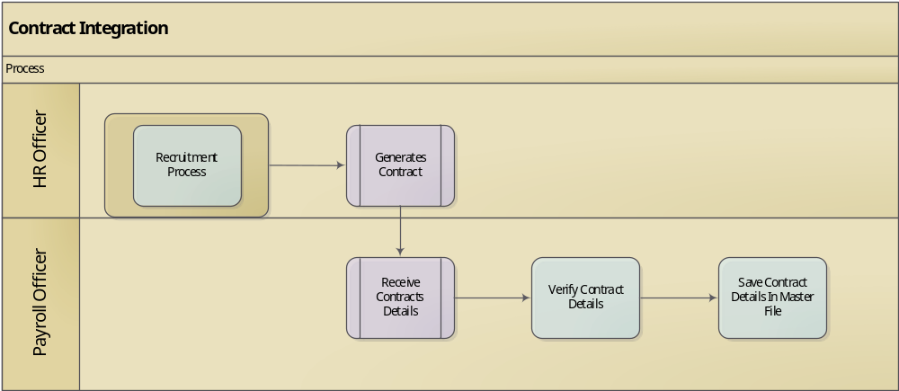

Actors
- HR Officer
- Payroll Officer

Workflow & Notification
- None Required

Audit trail
- Mine Number

Pre-Condition
- Timesheet
This is FC Platinum’s form used to fill the hours worked by an employee and leave taken.

Process Description
Human Resources Officer submits Summary sheets and physical timesheets to the Payroll officer in their respective pay points. At the same time the HR Officer filters the summary sheets and only selecting Labour Broking summary sheets and submit them to Accounting Officer Inventory and Revenue
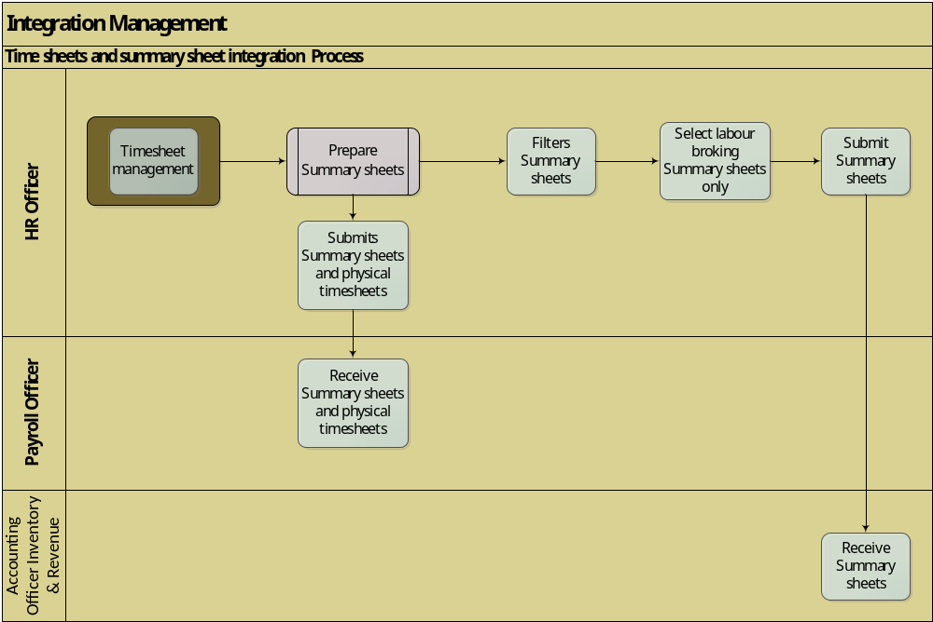

Actors
- Accounting Officer
- HR Officer

Workflow
- None required

Audit trail
- Summary sheet
- Timesheet

Inventory Management
Core Business
FC Platinum Inventory management (IM) is primarily about specifying the size and placement of stocked goods. It is necessary at different locations within the FC Platinum supply chain, to ensure continuity in the production cycle ensuring that there are no stock outs at any point. Inventory Management particularly ensures that FC Platinum has buffer stocks at all times.
. Inventory management can be defined as the management of stored materials and materials in transit the purpose of this procedure is to articulate the inventory control and management cycle at FC Platinum from start to end.

The following activities all fall within the range of inventory management:

- demand forecasting
- control of lead times,
- carrying costs of inventory and cost containment for inventory acquisition,
- inventory forecasting,
- inventory valuation,
- inventory visibility, what does this entail?
- future inventory price forecasting,
- physical inventory counts,
- available physical space for inventory,
- quality management,
- stocks replenishment, and
- returns of defective goods.
- Issuing of stock

Inventory management basically serves two main goals.

- Ensures the availability of goods to meet envisaged demand. It is important for the smooth-running operations, as effective and efficient IM ensures that required materials are present in the right quantities, quality and at the right time in order to deliver a specified service.
- Ensuring that the specified service level at attainable, pre-determined optimal costs.

Prerequisites
- Sites
FC Platinum currently has one main site configured namely: FCP main site.
- Warehouse
FC Platinum currently has the following warehouses configured
- Central Stores
- Chivasa
- Gazebo
- Mine Canteen
- Mine Canteen Kiosk
- Amenities
- Roland Golf Club Kitchen
- Roland Golf Club Bar
- Brickyard
- Cleaning
- Diverse Kitchen
- Diverse Bar
- Engineering
- PPE
- Regalia Main Stores
- Regalia Shop
- Stationery
- U19
- Locations.
FC Platinum currently has the following locations specified.

- Central Stores
- Chivasa
- Gazebo
- Mine Canteen
- Mine Canteen Kiosk
- Amenities
- Roland Golf Club Kitchen
- Roland Golf Club Bar
- Brickyard
- Cleaning
- Diverse Kitchen
- Diverse Bar
- Engineering
- PPE
- Regalia Main Stores
- Regalia Shop
- Stationery
- U19

- Products
Inventory relates to the perishable and non- perishable materials held by FC Platinum for resale and for production of goods or services

Receiving from Purchasing

Pre-condition
- Confirmed Purchase Order
Production of a fully approved and confirmed Purchase order due for receiving.
Availability of security for the receiving to proceed

Process Description
The Accounting Assistant - Procurement receives products from the delivering vendors, inspects them and then arranges products in their respective classes. In this respect goods are received in line with the respective Warehouses i.e. Cleaning for cleaning materials, PPE for protective clothing and Stationery for Stationery items

Goods can either be serialized or non-serialized.
For serialized goods the Accounting Assistant- Procurement uploads & attach serial numbers to products and then receive the available quantity into the respective site, warehouse and location.
For non-serialized goods the Accounting Assistant - Procurement will receive the delivered goods straight into the respective site, warehouse and location.

All receipts of goods must have the following information recorded and must be done in the presence of security personnel at all times:
- Receipt Date
- Delivery Note Number / Invoice Number/
- Quantity Received.
- Expiry Date (For goods that have a shelf life)
Defective and goods that do not conform to FC platinum quality standards will be rejected at the point of receipt and returned to supplier
Once the inspection, verification and receiving processes have been completed the Accounting Assistant -Procurement will produce and append signature to a Goods Received Voucher (GRV) and the same will be verified and signed by the security personnel and supplier representative.
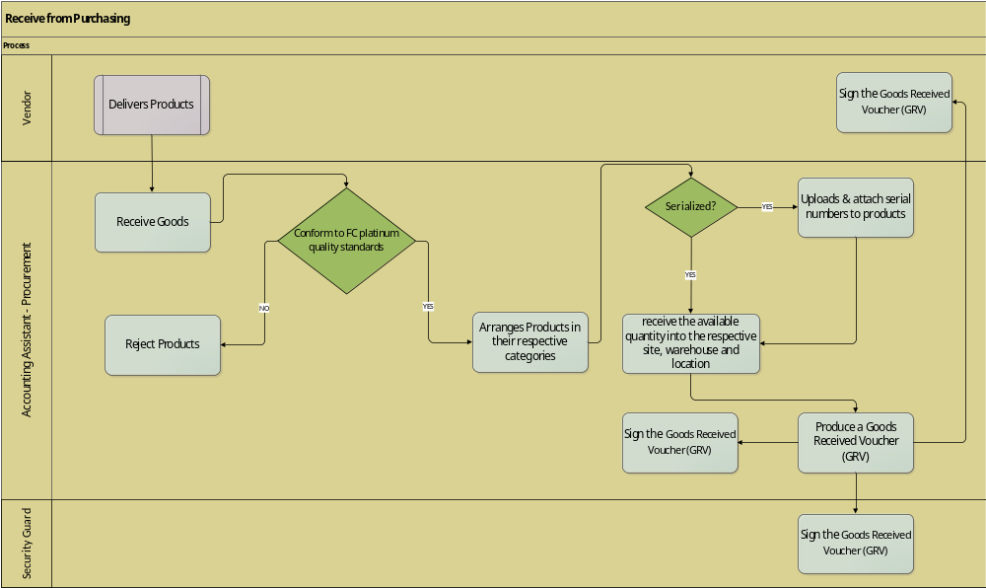

Actors
- Accounting Assistant -Procurement
- Vendor /Supplier
- Security personnel

Workflow & Notification
- None Required.

Audit Trail
- Goods Received Voucher (GRV)
- Supplier Delivery Note / Invoice
- Purchase Order Copy

Stock Issuing - Hospitality

Precondition
- Fully approved Inventory Requisition
- Stock availability
For stock to be issued, the Inventory Clerk need to be in possession of a fully approved stock requisition and checks to ensure the requested items of stock are available in the warehouse.

Process Description
Accounting Assistant-Inventory receives requisitions from the requesting department that is fully authorized by the respective Head of Section. Stock cannot be issued without an authorized stock requisition. Accounting Assistant-Inventory reviews and checks for the availability of goods requested for in the warehouse.
If the requested goods are not in stock the Accounting Assistant-Inventory will forward the requisition to procurement for replenishment into the main warehouse against this request’s reservation.
If the requested goods are in stock, Accounting Assistant-Inventory will send the requisition to the Accounting Officer-Inventory for Final Approval. Once approved the Accounting Assistant-Inventory instructs the Accounting Clerk-Inventory to physically issue stock to the Requesting Department.
The Accounting Clerk Inventory generates a Goods Issue Voucher (GIV) upon issuing the stock physically. On issuing Accounting Clerk-Inventory signs, the GIV to indicate that the products have been issued in the presence of security personnel who also. The requisitioning department representative also append signature as acknowledgment of receipt of goods.
The table below shows the User roles that Requisition and Approve for the respective warehouses where stock is transferred to for consumption.
 | Requisitioner | Head of section
Diverse | Head Chef | Lodges Supervisor
Gazebo | Bar man | Hospitality Supervisor
Roland | Bar man | Food & beverage supervisor
Chivasa | Head Chef | Hospitality Supervisor
Platinum Lounge | Bar man | Lodges Supervisor
Mine Canteen | Head Chef | Hospitality Supervisor

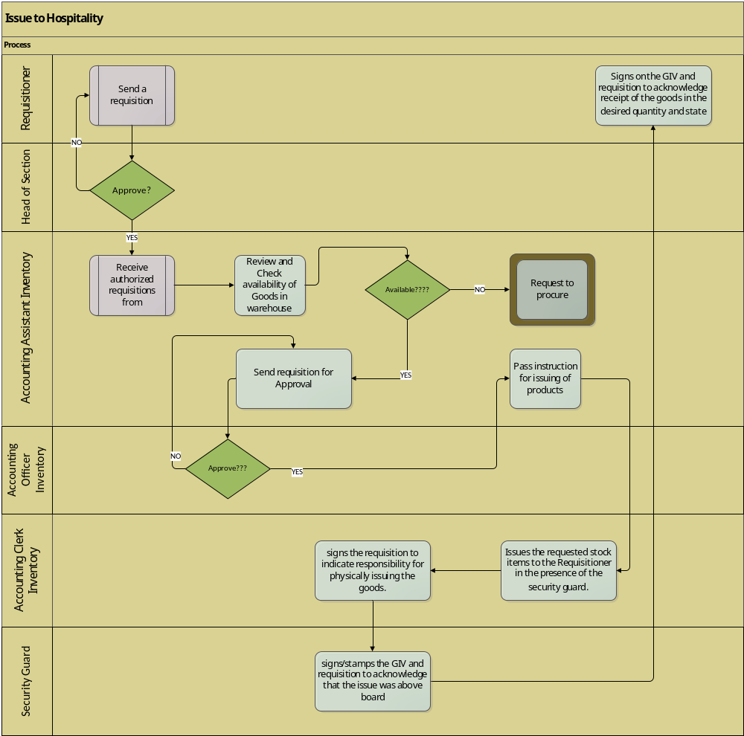

Actors
- Requisitioner
- Head of Section Requesting Department
- Head of Department Requesting Department
- Accounting Assistant Inventory
- Accounting Officer Inventory
- Accounting Clerk Inventory
- Security personnel

Workflow & Notification
- Approval of requisition by the Head of Section and Head of Department
- Review of requisition by Accounting Assistant Inventory.
- Approval of requisition by the Accounting Officer Inventory

Audit Trail
- Requisition
- Goods Issue Voucher. (GIV)

Issue to PPE

Precondition
- Fully approved Inventory Requisition
- Stock availability
- Conformance to the PPE Matrix
PPE has to be physically available in the Main warehouse.

Process Description

Accounting Assistant-Inventory receives a PPE requisition authorized by the respective Head of Section. PPE cannot be issued without an authorized stock requisition. Accounting Assistant- Inventory reviews and checks for the availability of the PPE requested for in the warehouse.
If the requested PPE is not in stock the Accounting Assistant-Inventory will forward the requisition to procurement for replenishment into the main warehouse against this request’s reservation.
If the requested PPE is in stock, Accounting Assistant- Inventory sends the requisition to the Accounting Officer Inventory for Approval. Once the Accounting Assistant Inventory approves the issue, the requisition is forwarded to the Accounting Clerk Inventory for the issuance of the requested inventory items. After issuing, the Accounting Clerk Inventory generates a Goods Issue Voucher (GIV) then issues the products physically.
After issuing the Accounting Clerk Inventory signs, the GIV to indicate that the PPE items have been issued in the presence of security who also append their signature, the requesting department’s representative also signs the GIV as acknowledgment of receipt. The GIV copies are printed in quadruplicate and distributed as follows
- Issuing Clerk
- Accounting Assistant Inventory
- Security
- HR
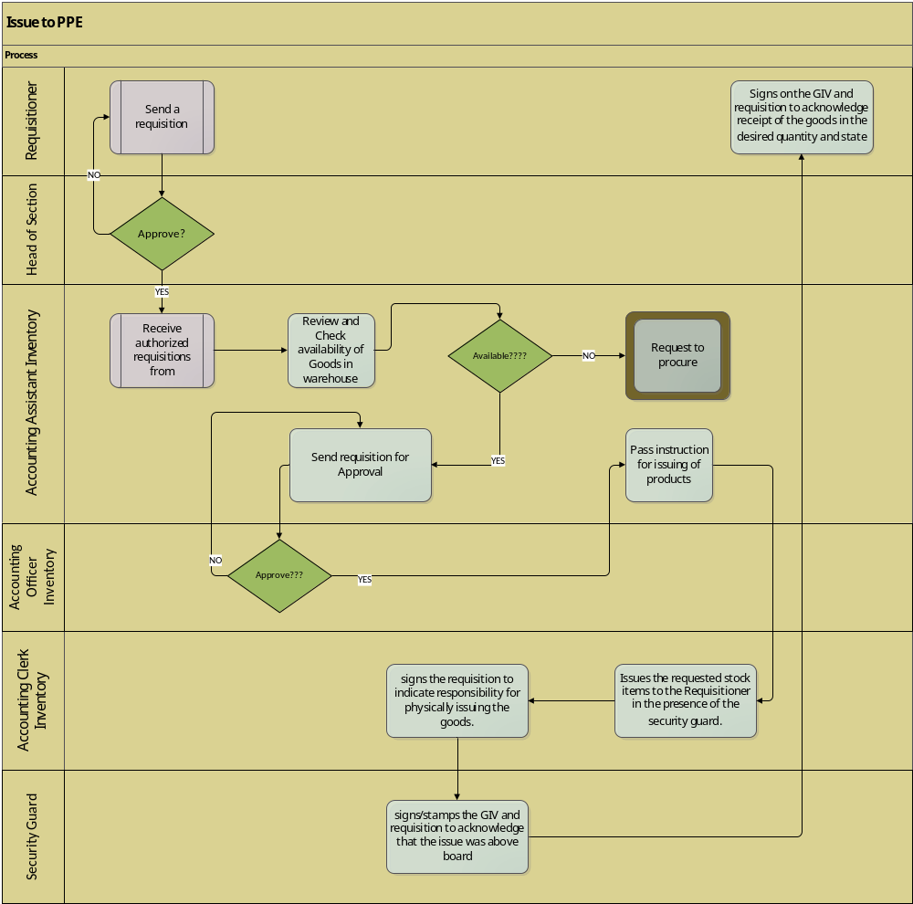

Actors
- Requisitioner
- Head of Section
- Accounting Assistant Inventory
- Accounting Officer Inventory
- Accounting Clerk Inventory
- Security personnel
- HR Officer

Workflow & Notification
- Review of requisition by the Accounting Assistant - Inventory
- Approval of requisition by the Accounting Officer Inventory

Audit Trail
- Requisition
- Goods Issue Voucher (GIV)

Issue internal consumption

Precondition
- Stock availability
The stock has to be physically available in main warehouse.

Process Description
Accounting Assistant Inventory receive requisitions from the requisitioner authorized by the respective Head of Section. Stock cannot be issues without an authorized stock requisition. Accounting Assistant Inventory reviews and checks for the availability of goods requested for in the warehouse.
If the requested goods are not in stock the Accounting Assistant-Inventory will forward the requisition to procurement for replenishment into the main warehouse against this request’s reservation.
If the requested for goods are in stock, Accounting Assistant Inventory send the requisition to the Accounting Officer-Inventory for Approval. Upon approval the Accounting Assistant-Inventory instructs the Accounting Clerk-Inventory to issue the products. The Accounting Clerk-Inventory generates a Goods Issue Voucher (GIV) then issues the products physically. Upon issuing Accounting Clerk Inventory signs, the GIV to indicate that the products have been issued in the presence of a security guard, he/she also signs and the requisitioner signs to acknowledge receipt of goods in good order.
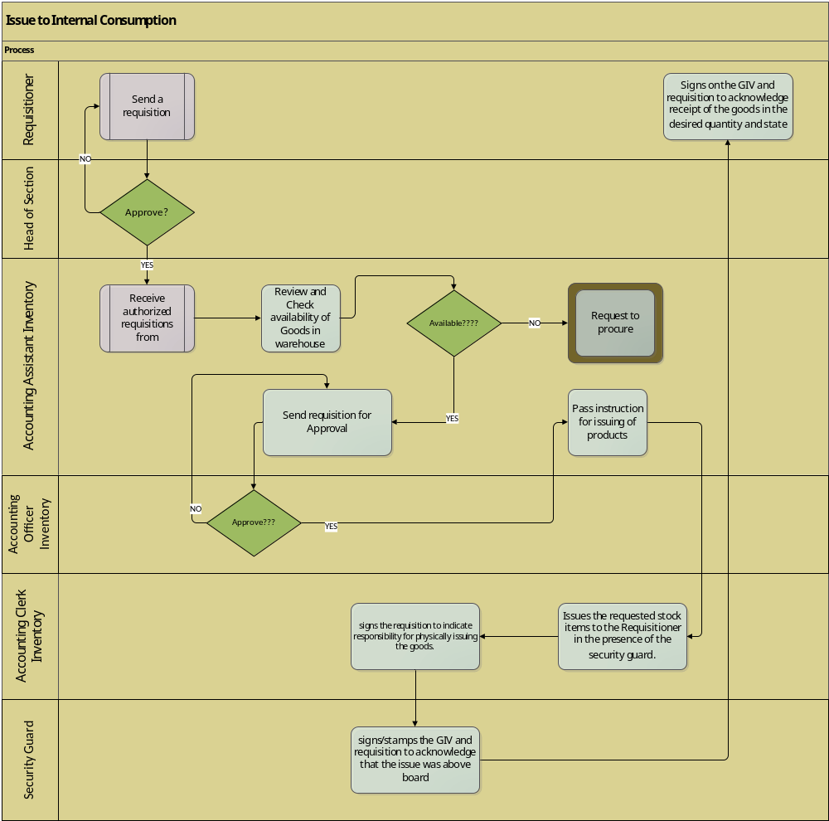

Actors
- Requisitioner
- Head of Section
- Accounting Assistant-Inventory
- Accounting Officer-Inventory
- Accounting Clerk-Inventory
- Security Guard

Workflow
- Approval of requisition by the Head of Section (HOS)
- Approval of requisition by the Accounting Officer -Inventory

Audit Trail
- Goods Issue Voucher (GIV)

Stock take

Precondition
- Stock
Stock must be available in the warehouse for it to be counted.
Prenumbered Stock count sheets
- Requisition of Audit
FC Platinum regularly verifies quantities and condition of the stock held in inventory or warehouses.

Process Description
Stock counts should be performed at Warehouses:

- Every Monday - to update bin cards and to check re-order levels- Hospitality stocks
- Every month ends
- – This is carried out to compare on hand inventory in the accounting system and physically counted quantities. The count is particularly important to guard against stock redundancy, unnecessary write offs due to expired goods. The ultimate goal is to report on the correct inventory quantity valued at the correct process on the financial statements. Any identified variances are investigated through a variance report and journalised to the accounts.
Before count, the Accounting Assistant Inventory ensures all stocks are grouped according to their nature for easy of identification and count. It is the responsibility of the Accounting Officer- Inventory to generate an inventory count sheet and create a count sheet register for use when issuing out the stock count sheets. Accounting Officer- Inventory identifies and sets up stock count teams. Each team must consist of one person from stores and one person from another department.
Accounting Officer - Inventory must
- conduct the training of the stocktaking teams a day before the count is done
- run a before count inventory valuation and print report for variance analysis.
- In conjunction with the Procurement Officer generate the following cut off documents;
- Last GRV.
- Last Issue Requisition
- Last Purchase Order Number
- Last Inspection Number

On the day of the count, the Accounting Officer Inventory issues out the stock count sheets to team leaders and ensures they sign for them. Stock take teams count items in the respective bins and record the count result in ink on the stock count sheet. The counted items should be marked to ensure no count duplications occur. Any cancellations should be neatly done and signed off by two team members including the team leader.
The Accounting Officer -Inventory evaluates the progress of the count, ensuring that all stock items have been counted. Once the count is completed, the Accounting Assistant-Inventory captures the stock count figures into a downloaded variance report and compare the system totals with the physical count. If any variances arise, the Accounting Clerk -Inventory initiates investigations on the identified variances and report on them. All stock variances should be cleared in the same reporting month. The stock custodian at all the FCP Locations shall be held accountable for the variances.
All stock count exercises shall be carried out in the presence of security.
The Accounting Officer-Inventory then
- processes the approved variances through journals
- generates and files the final inventory valuation.
- File completed and signed stock count sheets, variance report and stock take confirmations for future reference after confirmation.

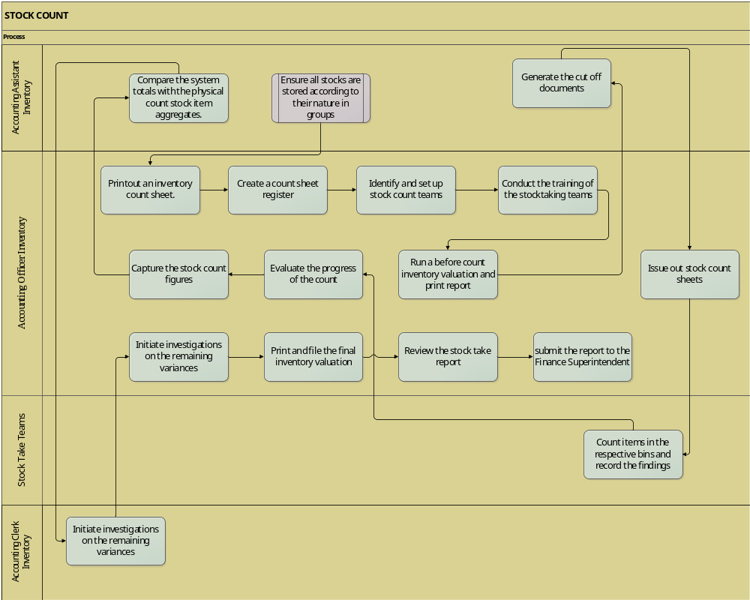

Actors
- Accounting Officer-Inventory
- Accounting Assistant Inventory
- Accounting Clerk Inventory
- Stock take teams
- Security Personnel

Workflow & Notification
- None Required

Audit Trail
- Stock Count Sheets
- Variance reports if there are identified variances

Month end Closure

Preconditions
- Ensure that all variances have been posted
- Check cost price variances
- Ensure open quantities are cleared
- Ensure that the most recent month end closure was conducted successfully

Process Description
At the end of each month the accounting officer closes the month and the system calculates the average cost of the product. The difference between the average cost of the products and the l the posted costs is then processed to costs. This procedure ensures that the inventory is valued in line with the FCP Inventory valuation Policy which is average cost

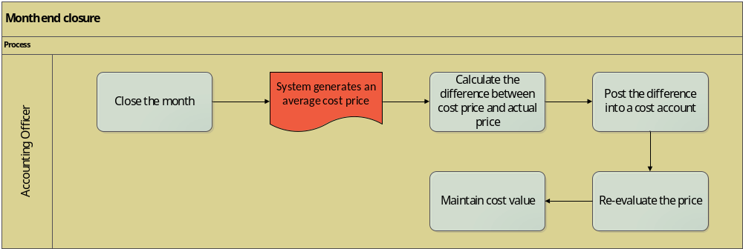

Actors
- Accounting Officer

Work floor
- None

Audit Trail
- None

Inventory Aging

Precondition
- Date
The date the item was capture in inventory has to be captured.
- Stock
Stock should be readily available in inventory for inventory aging to be performed.

Process Description
The accounting officer- Inventory runs an aging analysis report on demand. He checks the items/products on the periods. The more a product stays in inventory the bad the item it is i.e. items which is of a period of over 120 days is no longer usable therefore requires to be disposed depending on the type of product.
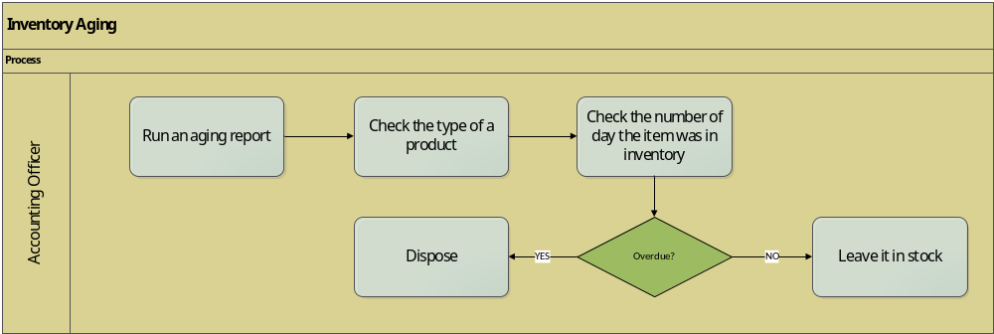

Actors
- Accounting officer

Work floor
- None

Audit Trail
- None

Procurement & Sourcing
Core Business
Procurement is the business management function that ensures identification, sourcing, access and management of the external resources that Fc Platinum needs or may need to fulfil its strategic objectives. Procurement exists to explore supply market opportunities and to implement resourcing strategies that deliver the best possible supply outcome to FC Platinum and its stakeholders and customers i.e. Mimosa Mine.

Prerequisites
- Vendor Categories
This is supplier classification depending of their line of business
- Vendor Criterion Group

- Vendor
A person or company offering something for sale

- Vendor account details
This include supplier bank details
- Department
A division in Fc Platinum depending o their line of business
- Requested Goods
Goods to be purchased

- Type of goods (inventory or non-inventory)

- Requester
A person who asks for something or who makes a request
- Position
This is a particular
- Anniversary
This is the date when allocation for new PPE is done
- Type of PPE Request
Protective clothes needed
- Approver
A person who endorses permission for request.

Supplier evaluation & Onboarding

Pre- Condition
- Vendor Categories
- Vendor Criterion Group

Process Description
Supplier evaluation is the process to access a new supplier based on their delivery, price, production, and quality of management, technical and services. A standard supplier evaluation framework is for all potential suppliers. The Accounting Officer Procurement identifies information about the potential suppliers of goods and services through end user recommendation or a tender committee. The Accounting Officer Procurement then groups potential suppliers into vendor groups, and request the vendor to fill in the application vendor form then analyzes supplier information obtained against the minimum required standards found in the vendor selection criterion. Below is a vendor registration form sample.


After the evaluation process is done the Accounting Officer Procurement submit selected Applications to the Finance & Admin superintendent for further verification and authorization before onboarding. The Accounting Officer Procurement sends feedback to qualifying vendors.
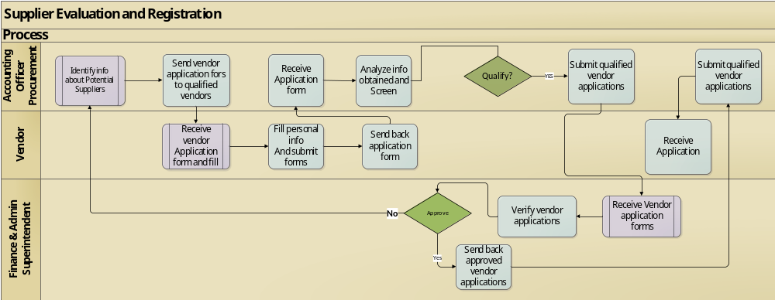

Actor
- Vendor
- Accounting Officer Procurement
- Finance & Admin Superintendent

Workflow
- Accounting Officer Procurement request for Approval
Finance & Admin Superintendent approval of vendor application forms.

Audit Trail
- Tax Status

Requisition Management

Request to Consume

Pre-Condition
- Requester
A person/ department who makes request for goods or services
- Type of goods (inventory or non-inventory)

Process Description
The Accounting Assistant-Inventory receives requisitions from end users, indicating the full details of information authorized by the respective Head of Section. The Accounting Assistant Inventory checks availability of Goods in stock. If the requested goods are available for issue the Accounting Assistant- Inventory issues the goods or services to the end user else the request is routed through the request to procure procedure (see process 1.4)
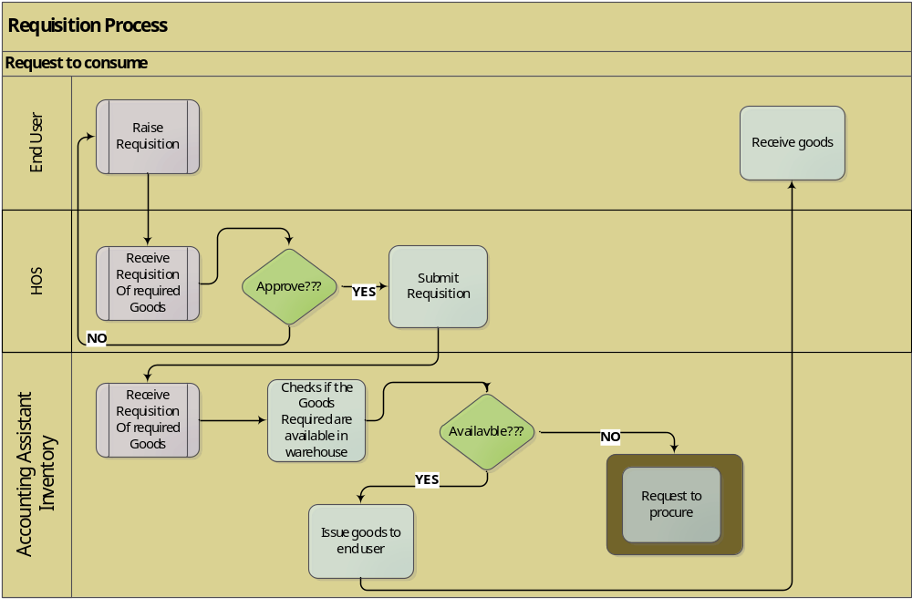

Actors
- End user
- Accounting Assistant-Inventory
- Head of Section

Workflow/Notification
- Request for approval from Originator
- Head of Section approval of stock requisition from end user

Audit Trail
- PR Number
- Requester ID
- PR Date

Request to Procure

Pre-Condition
- Approved Purchase Requisition (with no on hand stock)
Goods to be purchased
- Approved Supplier
A person or company offering goods and services for sale

Process Description
When the Accounting Assistant Inventory realises that the goods /services being requested for are not available in the warehouse, the Accounting Assistant Inventory regards the request as a request to procure the required goods or services. Request to procure can originate from the following sections
- Hospitality
- PPE
- Internal Consumption
The request to procure is then routed to the Procurement & Sourcing department to start the process of procuring the requested goods and or services.
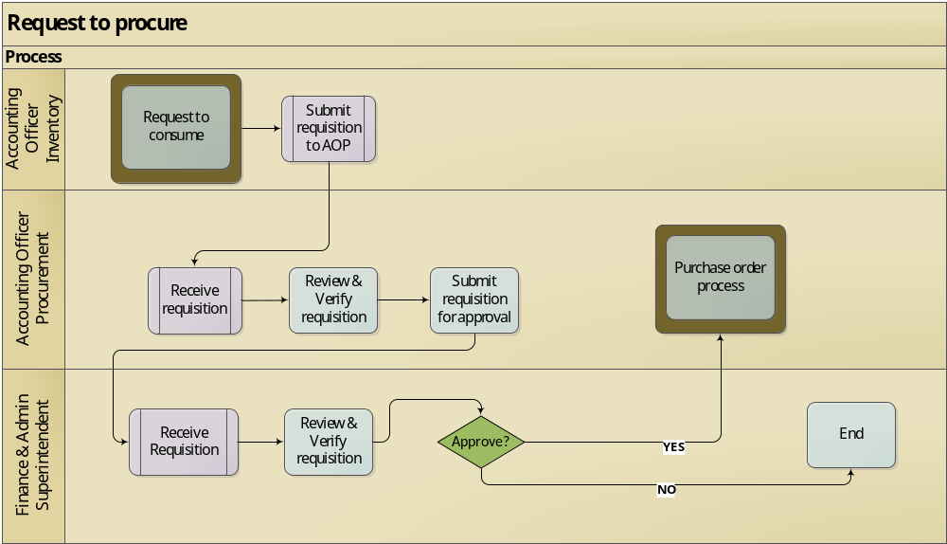

Actors
- Accounting Officer Inventory
- Accounting Officer Procurement
- Finance & Admin Superintendent

Workflow/Notification
- Finance & Admin Superintendent approval request to Procure from Accounting Assistant- Procurement.

Audit Trail
- Requisition form

Direct Purchase Request

Pre-Condition

Process Description
The Accounting Officer Procurement receives a purchase requisition direct from the end user. This request is done when goods and services that need to be procured are not found within the stock list of FC Platinum. The end user request for good /service clearly indicating the name and description then forwards to the Head of section for adjustments and approval. After approval request is forwarded to the Accounting Officer Procurement for assessment and adjustments. The Accounting Officer Procurement sends request to Finance and Admin Superintendent for approval when approved the Accounting Officer creates a purchase order for the approved request (see process 1.6).

Actors
- Accounting Officer Procurement
- Finance and Admin Superintendent

Work Flow
- Accounting officer Procurement request for approval
- Admin and Finance Superintendent approves purchase request.

Audit Trail
Requisition Number

Purchase Order Management

Pre-Condition
- Approved Vendor
A person or company offering goods for sale
- Vendor details
Supplier bank details
VAT number
Billing Address
Shipping Address

Process description

The Procurement Section shall be responsible for implementing the approved procurement strategies on a day to day basis in line with approved purchasing procedures. There are mainly types of purchase order which are:
- Standard.
- contract.
- Blanket.
- planned.
Accounting Officer Procurement receives at least 3 quotations from approved suppliers. If quotation is a capital expenditure General Manager or High level should approve else Finance & Admin can authorize. Accounting Officer Procurement forwards the authorized copy of the purchase orders to the supplier. Documents supporting the ordering of goods to be captured and filed. File documents supporting the ordering of goods and services in respective files and maintain a continuous register a of all orders raised.
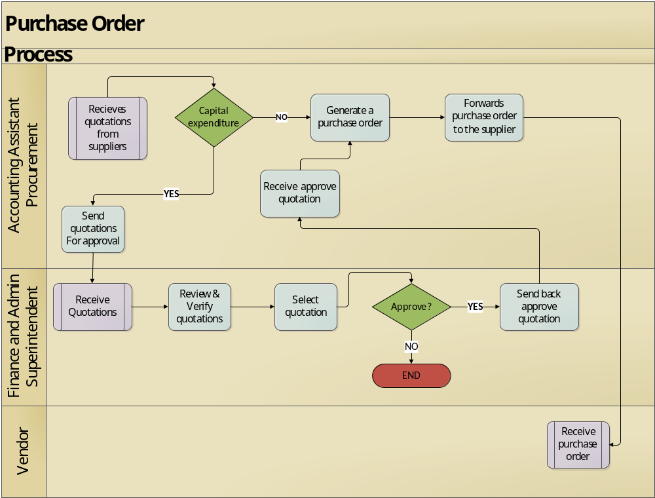

Actors
- Accounting Officer Procurement
- Finance & Admin Superintendent
- Vendor

Work Flow
- Finance & Admin Superintendent approves the Quotation document.

Audit Trail
- Quotation
- Purchase order

Receiving

Pre-Conditions
- Goods ID
Number that helps in identifying a product without a full specification specified.
- Type of Goods/ Services

Process Description
A receiving procedure is needed to properly inspect all incoming goods, mark them with tags, and record them as having been received. The Accounting Assistant matches the GRV, purchase order and supplier invoice details (Three (3) way matching) and posts agreeing sums into the computerized accounting package. Expiry dates of products should also be checked on receipt and any expired goods should be returned. Any quantity and quality variations noted should be reported to the Costing and Costing & Procurement Officer. This process should be done in the presence of the Security Guard at all times.
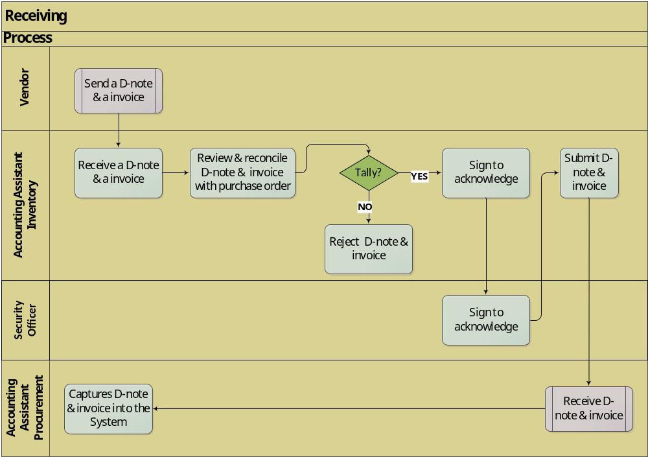

Field Description

Column Name | Datatype | Length
Name of Goods | Varchar | 45
Quantity | Num | 6
Date received | Date | 10

Actors
- Accounting Officer Procurement
- Accounting Assistant Inventory
- Security Officer
- Vendor

Work Flow
None

Audit Trail
- D-note
- Invoice

Accounts Payable
Core Business Process
Account Payables Management refers to the procedures and practices which are employed by FC Platinum with respect to managing its trade credit purchases. The AP activities consist of seeking trade credit lines, acquiring favorable terms of purchase, and managing the flow and timing of purchases so as to efficiently control the company’s working capital. AP Management is vital because the purchasing of inventory, raw materials, and other goods on trade credit allows a company to defer its cash outlays, while accessing resources immediately.

Prerequisites
- Purchase order
This is an invoices statement for the goods or services required to be purchased for use at the FC Platinum.
- Data Entity
This is a portal through which vendor invoices are received electronically by the Accounting Officer.
- Vendor invoices
Vendor invoices are the invoice statements clearly stating the amount owed or required by the vendor for goods or services acquired by various departments at the organization (FC Platinum).
- Product or service
These are goods or service acquired by the FC Platinum for consumption or resale or services offered by the vendor.
- Vendor
This is the supplier who supplies products/services.

Invoicing

Precondition
- Printed Invoice received
A printed invoice should be received by the Accounting Officer.
- GRV
The GRV should be signed to indicate that the goods have been received as required

Process Description
Once the goods have be confirmed that they have been received by the Accountant Assistant Inventory, the process of invoicing begins. The Accounting Officer receives a GRV and an invoice from the supplier and reconcile the GRV and the invoice against a purchase order and captures the invoice details. There are also invoices which cannot be reconciled against Purchase order. These invoices are received and captured into the system and then updates the invoice. Upon updating the invoice Creditors aging automatically updates, then the Accounting Officer reviews the Creditors account reflecting the balances FC Platinum owe its’ Creditors.

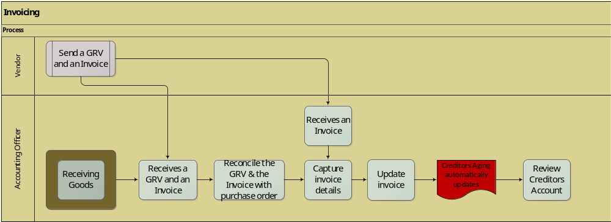
Invoice Details
Field Name | Datatype | Length
Vendor name | Varchar | 20
Address | Varchar | 45
Phone | Num | 20
Product/Service | Varchar | 30
Quantity | Num | 10
Cost | Num | 10

Actors
- Accounting Officer
- Vendor

Workflow
- None

Audit Trail
- Invoice
- GRV
- Purchase Order

Payment

Precondition
- Invoice
The supplier should have sent the invoice statement

Process Description
The Accounting Officer identify the invoice to be paid and request for a statement from the Supplier. Upon receiving invoice statement, the Accounting Officer match the invoice statement with the creditors account. If they match then payment is attached to the invoice and remittance is made else Accounting Officer settle the correct invoice with the supplier then payment is attached to the invoice then remittance is made.
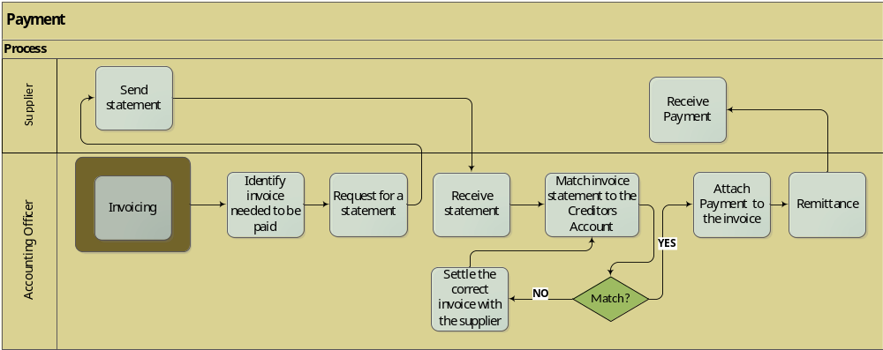

Actors
- Accounting Officer
- Supplier

Workflow
- None

Audit Trail
- Invoice

Aging Analysis

Precondition
- Vendor
This is the supplier who supplies products ordered to FC Platinum.
- Invoice
This is a document statement which reflects the balances FC Platinum owes its creditors.

Process Description
The Accounting Officer runs an aging analysis report on the system and print it. He then reviews the report and analyze it and make decisions. The Accounting Officer can either Age by Invoice Date / document Date.

Age by Posting date
- Date the invoice was posted.
Age by Document
- Date on invoice document.

Aging Buckets
Period (Days) | Description
0 – 30 | Current period
31 – 60 | 60 days
61 – 90 | 90 days
91 – 120 | 120 days
Over 120 | 120+ days

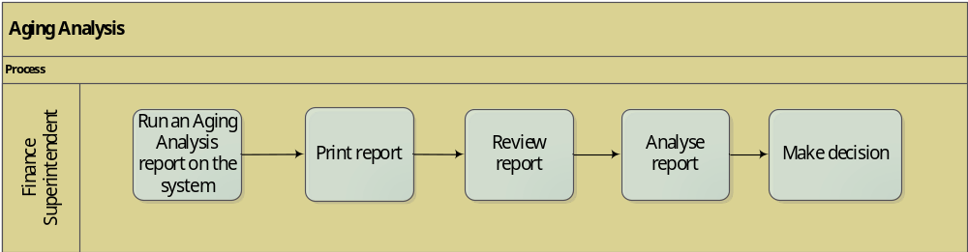

Actors
- Accounting Officer

Workflow
- None

Audit Trail
- Aging report

Revaluation

Precondition
- Invoice
This is a statement which reflects the balances FC Platinum owes its creditors.
- Foreign currency invoice
The invoice has to be foreign for it to be revaluated.
- Date
The day should be the last day of the month.

Process Description
At the end of each month all foreign currency invoices are revaluated. The Finance Superintendent load the current rate as of last day of the month then revalue vendor invoice balance the invoice with that rate. All foreign currency invoices should reflect the new revaluated balance owed by FC Platinum. When the payment is made later on, it is paid using the current prevailing rate of the day. The difference between the paid amount and the invoice amount is posted to the Profit/Loss account.
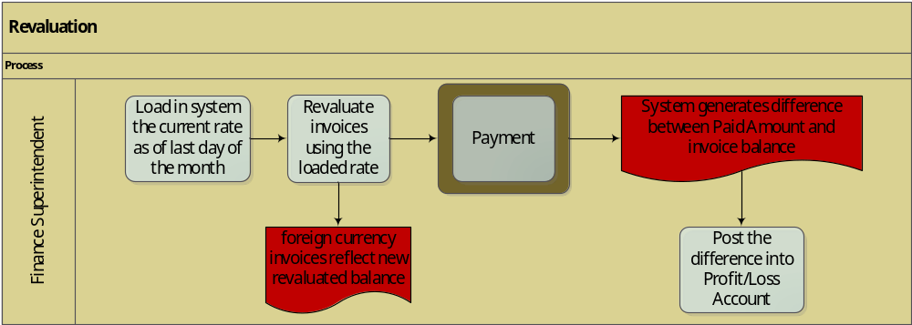

Actors
- Accounting Officer

Workflow
- None

Audit Trail
- Current rate
- Payment

